For your Nilus Kitchen Demo 4 backend, the .env file contains a mixture of settings you choose yourself, values supplied by a service, and values that depend on which service you use.
You do not need to collect all of them from one website. I'll explain where each value comes from, how to obtain it, and what to put in your .env file.
1. First, understand which values you need
.env variable | Where its value comes from | What you need to do
JWT_SECRET | You generate it | Create a long, random secret
OWNER_REGISTRATION_CODE | You choose or generate it | Create a private code for owner registration
EMAIL_HOST | Gmail SMTP configuration | Use smtp.gmail.com for Gmail
EMAIL_PORT | Gmail SMTP configuration | Use 465 for SSL, or 587 for STARTTLS
EMAIL_USER | Your Gmail account | Enter your Gmail address
EMAIL_PASS | Your Google Account | Generate a Google App Password
EMAIL_FROM | Your email configuration | Usually use your Gmail address
GEMINI_API_KEY | Google AI Studio | Create an API key if you implement AI
GEMINI_MODEL | Google's supported model list | Choose a model compatible with your API key
Important: For Version 4.1 (without AI), you can leave the Gemini variables empty if your backend does not require them. For Version 4.2 (AI-assisted order extraction), you'll need to configure them when you implement that feature.
2. Generate JWT_SECRET
What is it?
JWT_SECRET is a private secret your backend uses to sign and verify JSON Web Tokens (JWTs). In Nilus Kitchen, a token can prove that the owner has logged in when they request protected dashboard routes.
You should generate your own secret rather than copy one from a tutorial.
Steps in VS Code
- Open the VS Code terminal in your backend folder.
- Run this command:
node -e "console.log(require('node:crypto').randomBytes(32).toString('hex'))"
- Node.js will print a long, random value.
- Copy the generated value.
- Paste it after JWT_SECRET= in your .env file.
For example, the output will look like a long string of random hexadecimal characters. The example below is only illustrative, not a secret you should use:
JWT_SECRET=paste_your_generated_secret_here
Node.js provides crypto.randomBytes() to generate cryptographically strong random data.

GitHub
+1
Important: Keep this value private. If you change it after users have logged in, existing tokens signed with the previous secret will generally stop working.
3. Generate OWNER_REGISTRATION_CODE
What is it?
This is a private code that your backend can require when someone attempts to register an owner account.
For your current single-owner dashboard, it can help prevent random visitors from creating owner accounts, provided your registration controller actually checks the code.
It is not automatically generated by Express, MongoDB, or JWT. You choose it or generate it yourself.
Steps
- Open your VS Code terminal in the backend folder.
- Run:
node -e "console.log(require('node:crypto').randomBytes(16).toString('hex'))"
- Copy the generated string.
- Add it to .env:
OWNER_REGISTRATION_CODE=paste_your_generated_code_here
- Later, when you build the registration endpoint, the backend must compare the submitted registration code with process.env.OWNER_REGISTRATION_CODE.
Do not use an easy code such as 123456, your business name, or your email address.
A security note: The registration code should be checked on the backend, never exposed in React frontend code. For a production owner account, also consider disabling public registration after the initial owner account is created.
4. Where did EMAIL_HOST=smtp.gmail.com come from?
This value comes from Gmail's SMTP server configuration. SMTP stands for Simple Mail Transfer Protocol; it is a standard way for your backend to send emails.
For Nilus Kitchen, you wanted to send an email verification link after registration. If you're using Gmail to send those emails, your configuration uses:
EMAIL_HOST=smtp.gmail.com
You don't generate this value yourself. It is Gmail's server hostname.
If you later switch to another email provider, you may need to change the hostname, port, and authentication settings.
Where to find the official information
- Google: Check Gmail through other email platforms
- Nodemailer: SMTP configuration documentation
5. Where did EMAIL_PORT=465 come from?
The port number is part of the SMTP connection configuration. It is not your Express server's port (PORT=5000).
The two commonly used SMTP options are:
Environment variable | Meaning
EMAIL_PORT=465 | SMTP over implicit SSL/TLS
EMAIL_PORT=587 | SMTP with STARTTLS, typically starting the connection without TLS and upgrading it
These are standard SMTP connection options supported by Nodemailer. See its SMTP documentation.
For the configuration we've been using, we'll keep port 465, which requires a matching Nodemailer setting:
const transporter = nodemailer.createTransport({
host: process.env.EMAIL_HOST,
port: Number(process.env.EMAIL_PORT),
secure: true,
auth: {
user: process.env.EMAIL_USER,
pass: process.env.EMAIL_PASS
}
});
Here, secure: true matches port 465. If you instead use port 587, you'd normally use secure: false and let Nodemailer upgrade the connection using STARTTLS.
6. Get EMAIL_USER
This is the Gmail address your backend will use to send verification emails.
Steps
- Decide which Gmail account you want to use for Nilus Kitchen.
- Sign in to that account.
- Put its full address in .env.
For example, if your chosen Gmail address were niluskitchen.example@gmail.com, you would write:
EMAIL_USER=niluskitchen.example@gmail.com
Use your own real address, not the example.
For the initial project, you can use one Gmail account as both the sender and the account used to authenticate with Gmail.
7. Get EMAIL_PASS — your Gmail App Password
This is not your normal Gmail password. An App Password is a separate 16-character passcode Google can provide for applications that need to sign in through a method that doesn't offer Google's usual sign-in flow. Google requires 2-Step Verification for App Passwords.
Google Account Help
+1
Since you've mentioned that you already have 2-Step Verification enabled, follow these steps.
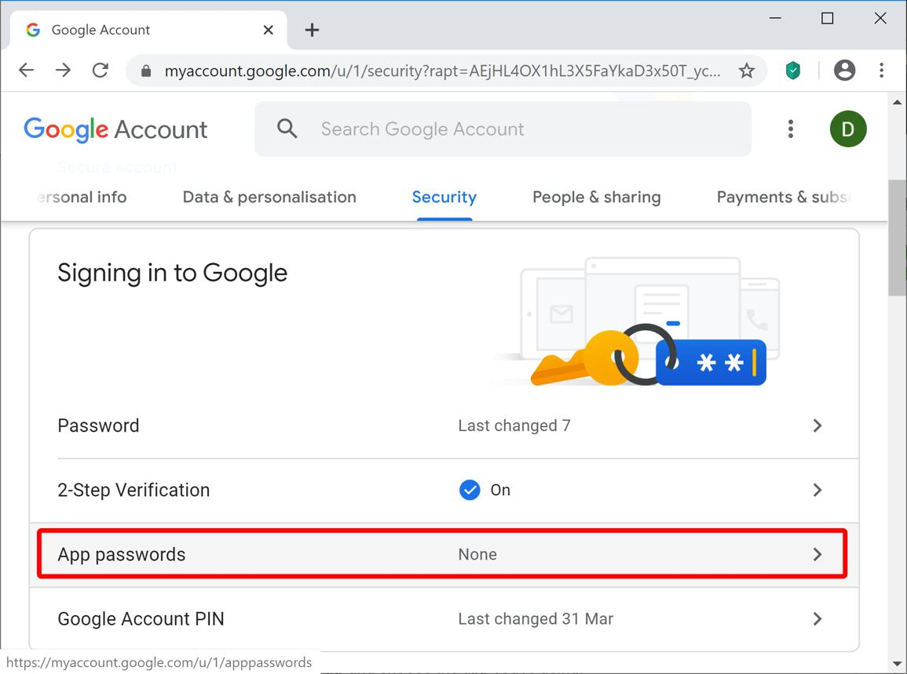
Step 1 — Open your Google Account security settings
Go to Google Account Security.
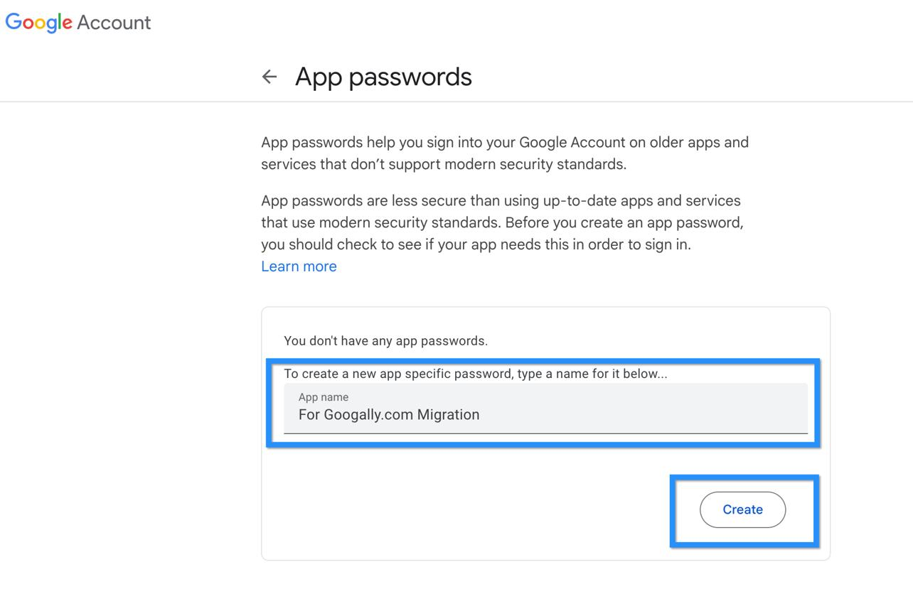
Step 2 — Find App Passwords
Under your account's sign-in settings, look for App passwords. You may be asked to sign in again.
You can also try the direct Google App Passwords page.
Step 3 — Create an App Password
If Google offers the option, follow its prompts to create one. You may be asked to provide an identifying label, such as Nilus Kitchen Backend.
Step 4 — Copy the generated password
Copy the displayed passcode and store it privately. Google may show it only once.
Step 5 — Paste it into .env
EMAIL_PASS=paste_your_app_password_here
Use the generated App Password, not your regular Gmail password.
If Google doesn't show the App Password option, check its official troubleshooting guidance. Some account configurations do not support it.
Never send your App Password to anyone or commit it to GitHub.
8. What is EMAIL_FROM?
EMAIL_FROM specifies the sender address that appears on outgoing emails.
For this project, use the same Gmail address as EMAIL_USER:
EMAIL_USER=your_real_gmail@gmail.com
EMAIL_FROM=your_real_gmail@gmail.com
For example, the registration verification email might display:
- From: your Gmail sender address
- Subject: Verify your Nilus Kitchen account
You don't need to generate EMAIL_FROM or obtain it from a separate website. It is your chosen sender address. Using the same address for authentication and sending is the simplest setup for this project.
9. Get GEMINI_API_KEY
This is required only for the AI-assisted version of Nilus Kitchen, where the backend might extract food items and quantities from a customer's message.
You obtain the key from Google AI Studio, not from VS Code or MongoDB.
Steps
- Open Google AI Studio and sign in with your Google Account.
- Open the API Keys section of the dashboard.
- If necessary, create or select a Google Cloud project that you have permission to use.
- Choose the option to create an API key and follow the prompts.
- Copy the generated key and keep it private.
- Paste it into your backend .env file.
Your setting will look like this:
GEMINI_API_KEY=paste_your_actual_api_key_here
Google's official guide explains key creation, project requirements, and how to configure keys securely.

Google AI for Developers
+1
Important: Keep the key in the backend .env file. Do not put it in React code, expose it through an API response, or use a VITE_ prefix for it.
10. Get GEMINI_MODEL
This is the model identifier your backend passes to the Gemini API. It is not another secret and you don't generate it.
For example, Google's model documentation currently lists gemini-3.8-flash as a stable model. Availability and supported models can change, so choose a model from the current official list and confirm that it works with the API and SDK you implement.
Google AI for Developers
+1
Steps
- Open the official Gemini API models list.
- Choose a model appropriate for extracting structured order details from messages.
- Copy its exact model ID.
- Put that ID into .env.
For example:
GEMINI_MODEL=gemini-3.8-flash
This is an example of the format, not a guarantee that this model is the best fit for your eventual implementation.
If you're still building the non-AI version, you can leave both Gemini values blank:
GEMINI_API_KEY=
GEMINI_MODEL=
Your application must be written to avoid calling Gemini while these values are empty.
11. Your corrected .env file
Here is the combined template for your project. Keep the database name you selected, nilus_kitchen_demo_4.

PORT=5000
NODE_ENV=development

MONGODB_URI=mongodb://127.0.0.1:27017/nilus_kitchen_demo_4

CLIENT_URL=http://localhost:5173
API_BASE_URL=http://localhost:5000

JWT_SECRET=paste_your_generated_jwt_secret_here
JWT_EXPIRES_IN=1h

OWNER_REGISTRATION_CODE=paste_your_generated_registration_code_here

EMAIL_HOST=smtp.gmail.com
EMAIL_PORT=465
EMAIL_USER=your_real_gmail@gmail.com
EMAIL_PASS=paste_your_gmail_app_password_here
EMAIL_FROM=your_real_gmail@gmail.com

GEMINI_API_KEY=
GEMINI_MODEL=
Replace every placeholder with your own value where required. The MongoDB URI, localhost URLs, Gmail SMTP hostname, and port can stay as shown for this local setup.
A few important rules:
- Keep .env in your backend directory, where your backend configuration expects it.
- Make sure .env is listed in .gitignore.
- Restart your backend after changing environment variables.
- Check that your email service uses EMAIL_HOST, EMAIL_PORT, EMAIL_USER, EMAIL_PASS, and EMAIL_FROM—the variable names must match your code.
- For deployment, set the corresponding environment variables in your hosting provider's settings; your local .env file is not automatically transferred to Vercel.
Recommended order for your current build
- Generate and configure JWT_SECRET.
- Generate and configure OWNER_REGISTRATION_CODE.
- Decide which Gmail account will send verification emails.
- Set EMAIL_USER and EMAIL_FROM to that address.
- Generate the App Password and set EMAIL_PASS.
- Keep the Gmail host and port as shown, then test sending a verification email.
- Leave Gemini variables empty until you begin implementing the AI version.
That way, you can finish the authentication and email-verification setup for the non-AI version before adding the additional Gemini configuration.

